**The Skyscraper Technique - ( Backlinks + Traffic ) to the Blog**

**Step by Step**

* Targeted keywords for our blog.
* Google top results for these keywords.
* SEMrush to find the website giving backlinks to these top Google Results we have analysed.
* Finding the websites’ contact details using Email Hunter.
* Reaching out to them and presenting our blog link. For sending bulk mails we'll use GMass for this.
* Suggesting a link back to our website.

**Blog-** <https://www.systango.com/blog/frameworks-for-cross-platform-app-development-flutter-vs-xamarin-vs-react-native/>

**Top Competitor Blogs**

[**https://www.netsolutions.com/insights/cross-platform-app-frameworks-in-2019/**](https://www.netsolutions.com/insights/cross-platform-app-frameworks-in-2019/)

[**https://appinventiv.com/blog/cross-platform-app-frameworks/**](https://appinventiv.com/blog/cross-platform-app-frameworks/)

[**https://www.mobileappdaily.com/top-cross-platform-app-devp-frameworks**](https://www.mobileappdaily.com/top-cross-platform-app-devp-frameworks)

[**https://hackernoon.com/9-popular-cross-platform-tools-for-app-development-in-2019-53765004761b**](https://hackernoon.com/9-popular-cross-platform-tools-for-app-development-in-2019-53765004761b)

[**https://www.gurutechnolabs.com/cross-platform-frameworks-for-mobile-app-development/**](https://www.gurutechnolabs.com/cross-platform-frameworks-for-mobile-app-development/)

[**https://aglowiditsolutions.com/blog/top-cross-platform-mobile-development-tools/**](https://aglowiditsolutions.com/blog/top-cross-platform-mobile-development-tools/)

[**https://blog.logrocket.com/flutter-vs-react-native-vs-xamarin/**](https://blog.logrocket.com/flutter-vs-react-native-vs-xamarin/)

**Referring domains for top competitor blogs -**

**App inventiv- 22**

**Net solution-21**

**mobileapp daily- 15**

**hackernoon- 34**

**guru technolabs- 13**

**aglowiditsolutions- 20**

**Logrocket-36**

**Total- 161 referring domains ie, 161 mails to be sent.**

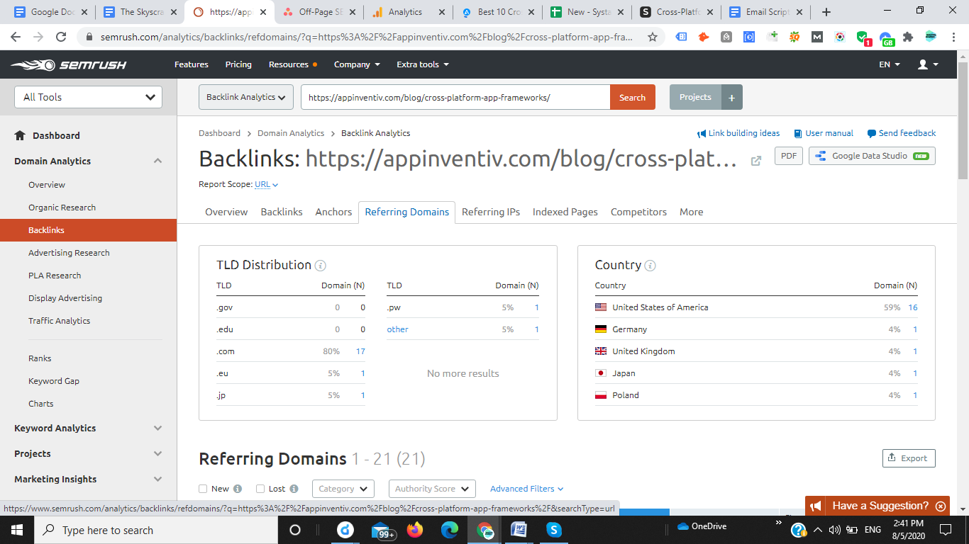

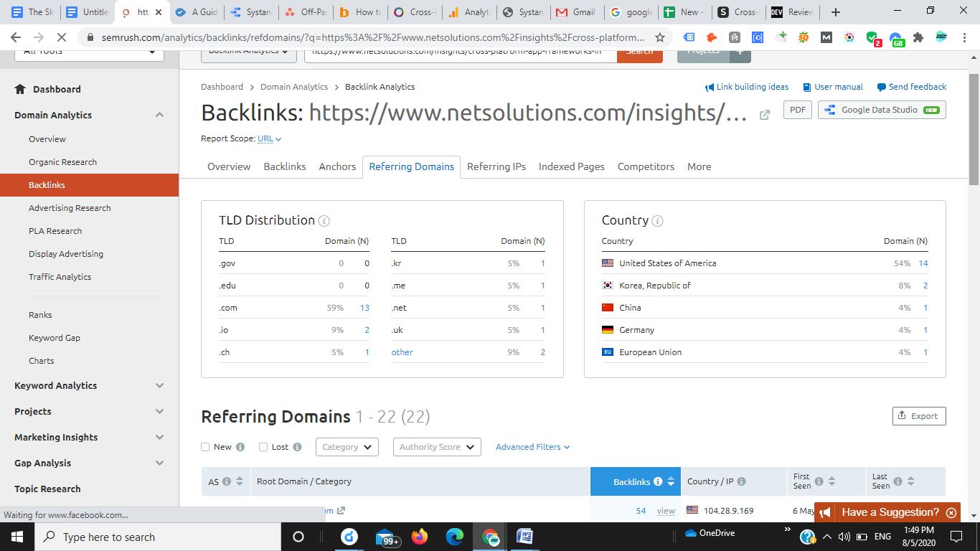

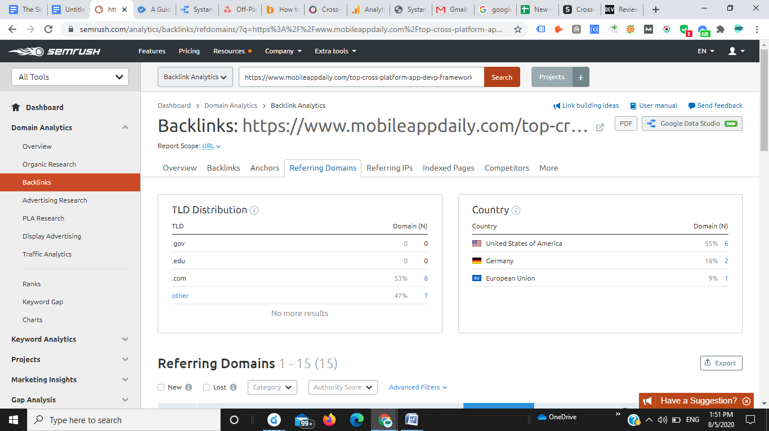

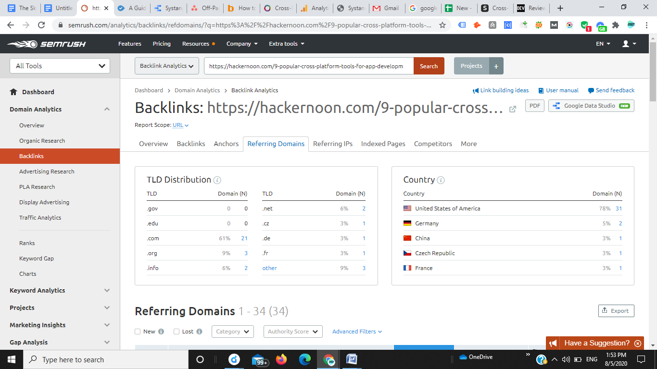

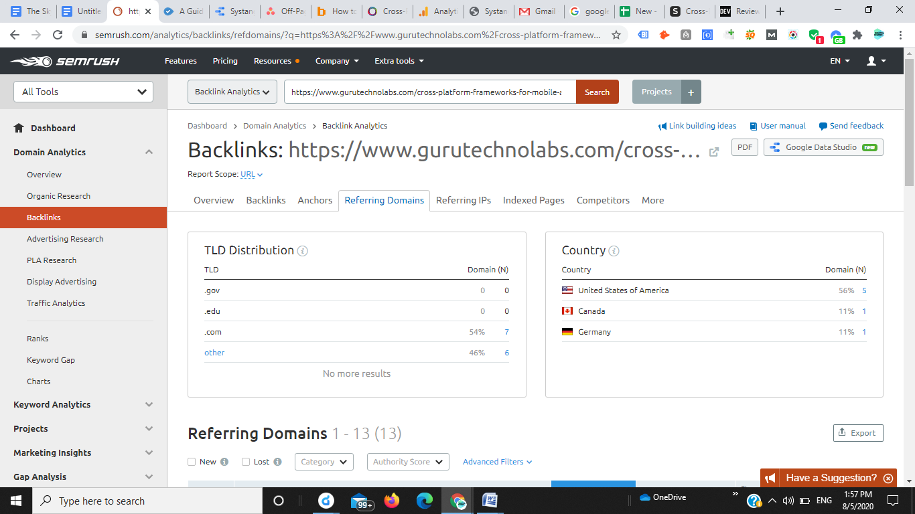

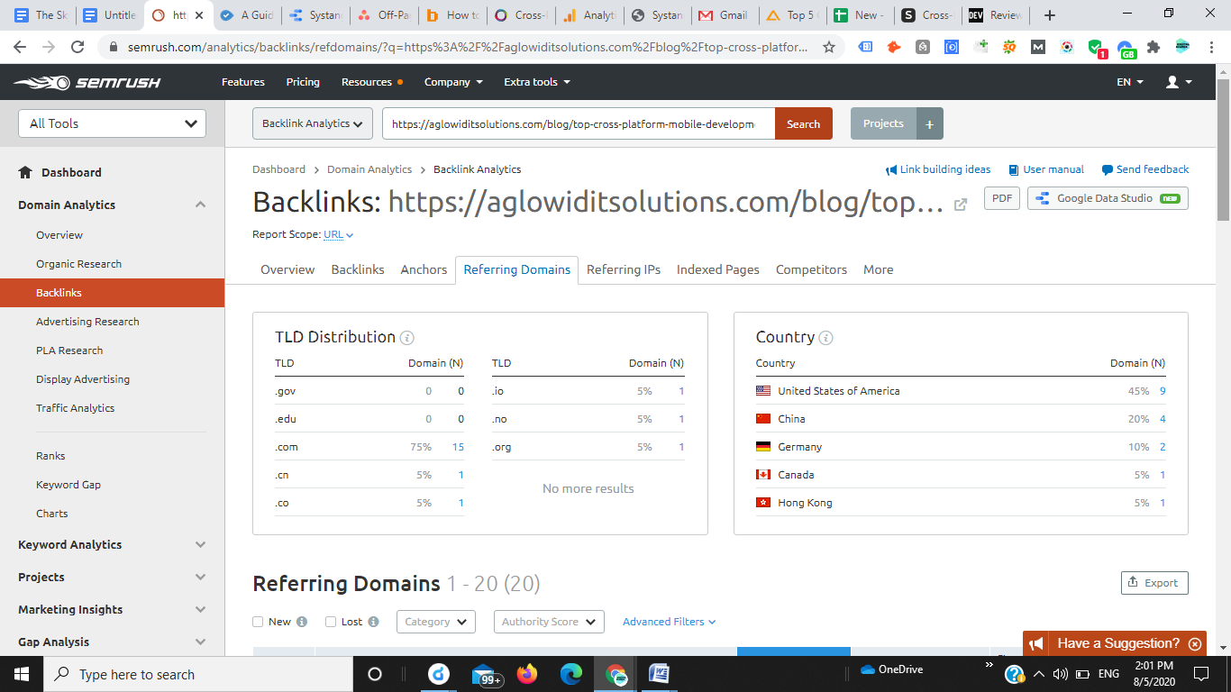

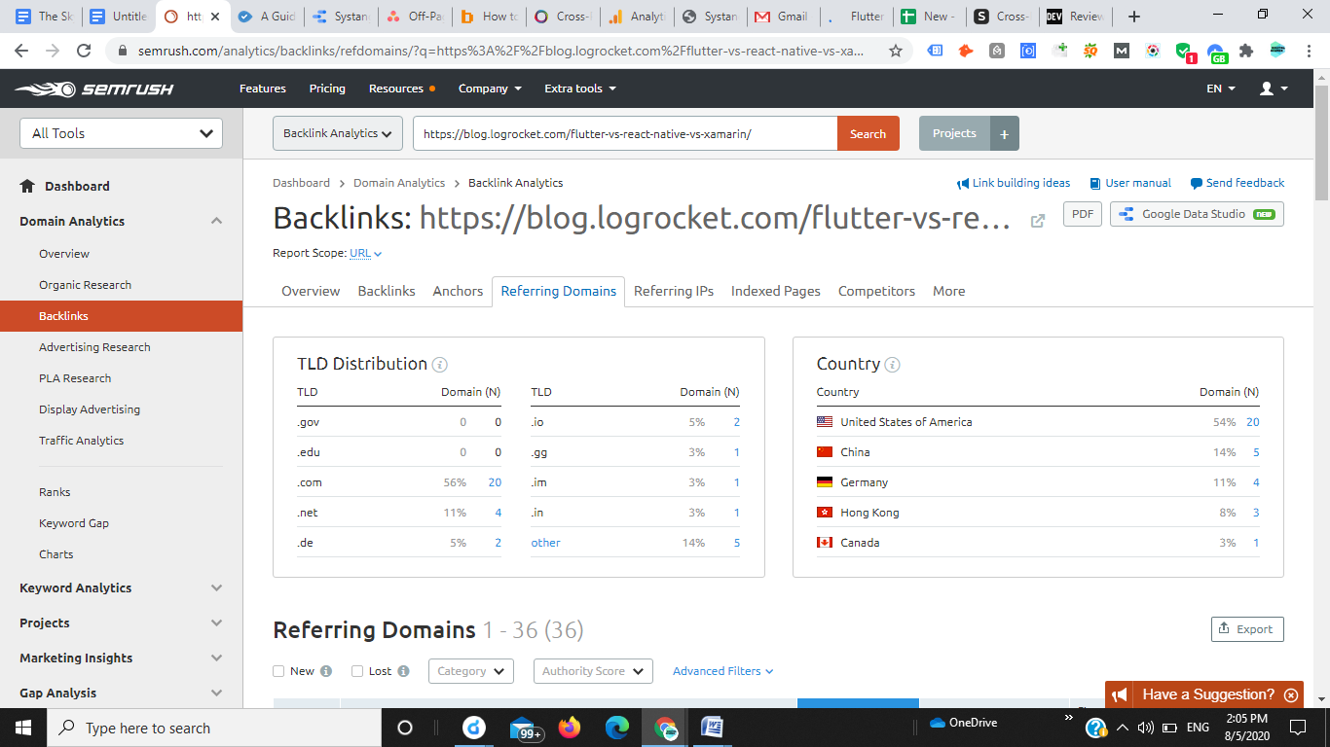

**Email Address for these 161 referring domains can be found using Email Hunter.**

**Email script to be sent ( can be edited)**

I was checking out some of the articles on your site and found your post about cross platform app development.

Great stuff!

I couldn’t help but notice you linked to that classic blog about frameworks for cross platform app development.

<https://appinventiv.com/blog/cross-platform-app-frameworks/>

I also love that resource,

In fact, it inspired me to create a more thorough and up to date version. Here’s the link of the blog in case you would like to check it out.

<https://www.systango.com/blog/frameworks-for-cross-platform-app-development-flutter-vs-xamarin-vs-react-native/>

It might be worth a mention on your page.

Either way, keep inspiring with your awesome work!

Cheers!

**Note- This technique is primarily used to get good traffic from high DA sites. Out of 161 if we are able to get 10+ links, all our effort will be worth it.**